7.3.15 Editors - 3D View - Sidebar - Tool Tab - Grease Pencil - Layer Panel
Layer Panel 1
Layer list 2
Layer name 2
Mask Layer 2
Onion Skinning 2
Viewport/Render Visibility 2
Lock 2
Search Field 2
Add new layer 2
Remove layer 2
Layer Specials 2
Duplicate Layer 2
Show All 2
Hide Others 2
Lock All 3
Unlock All 3
Autolock inactive layer 3
Merge Down 3
Copy Layer to Object 3
Isolate Layer 3
Isolate Layer 3
Blend 3
Opacity 3
Mask Layer 3
Use Lights 3

Layer Panel

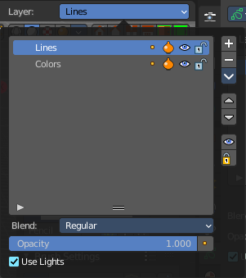
The content of the Tool tab in the sidebar and the tool settings above the 3D view is usually equal. The Layer panel is a special panel in this regards. It just exists in the tool settings above the 3Dview. And it exists in all grease pencil modes but the object mode.

Grease Pencil objects each have a list of 2D layers for grouping and arranging strokes in a List view. Any stroke can only belong to a single 2D layer. There is always only one active layer in the list (the selected one). When you draw, the new strokes are added to the active layer. By default the view order of the layers in the viewport is top to bottom.

Every layer correspond to a channel in the Dope Sheet editor (in Grease Pencil mode). Layers can also be used together with Modifiers to only affects part of your drawing.

Layer list

Layer name
The name of the layer.

Mask Layer
Toggle the Masks visibility in the layer.

Onion Skinning
Toggle the use the layer for Onion Skinning.

Viewport/Render Visibility
Toggle layer visibility in the viewport and in render.

Lock
Toggle layer from being editable.

Search Field

You can expand a search field at the bottom of the list. Type in your term and hit enter to filter for your term.

Add new layer
Adds a new layer.

Remove layer
Removes the selected layer.

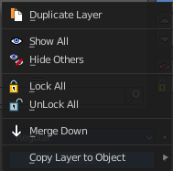
Layer Specials

Duplicate Layer
Makes an exact copy of the selected layer appending a number to differentiate its name.

Show All
Turns on the visibility of every layer in the list.

Hide Others
Turns off the visibility of every layer in the list except the active one.

Lock All
Locks edition of all the layers in the list

Unlock All
Unlocks edition of all the layers in the list.

Autolock inactive layer
Locks automatically the edition of every layer in the list except the active one. This way you avoid to make unwanted changes in other layers without the need to lock them every time.

Merge Down
Merge the selected layer with the layer below, the new layer keeps the name of the lower layer.

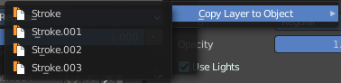
Copy Layer to Object
Makes a copy of the layer and move it to the selected Grease Pencil object.

Isolate Layer
Hide and lock the layer.

Isolate Layer
Lock the layer.

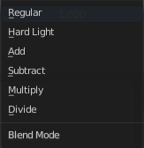
Blend
The layer blending operation to perform. See Color Blend Modes.

Opacity
Used to set the opacity of the layer.

Mask Layer
Toggle the Masks visibility in the layer.

Use Lights
When enabled, the layer is affected by lights.

